NASSAU COUNTY LEGISLATURE
15th TERM MEETING AGENDA
GOVERNMENT SERVICES & OPERATIONS COMMITTEE
JANUARY 8, 2024 1:00 PM

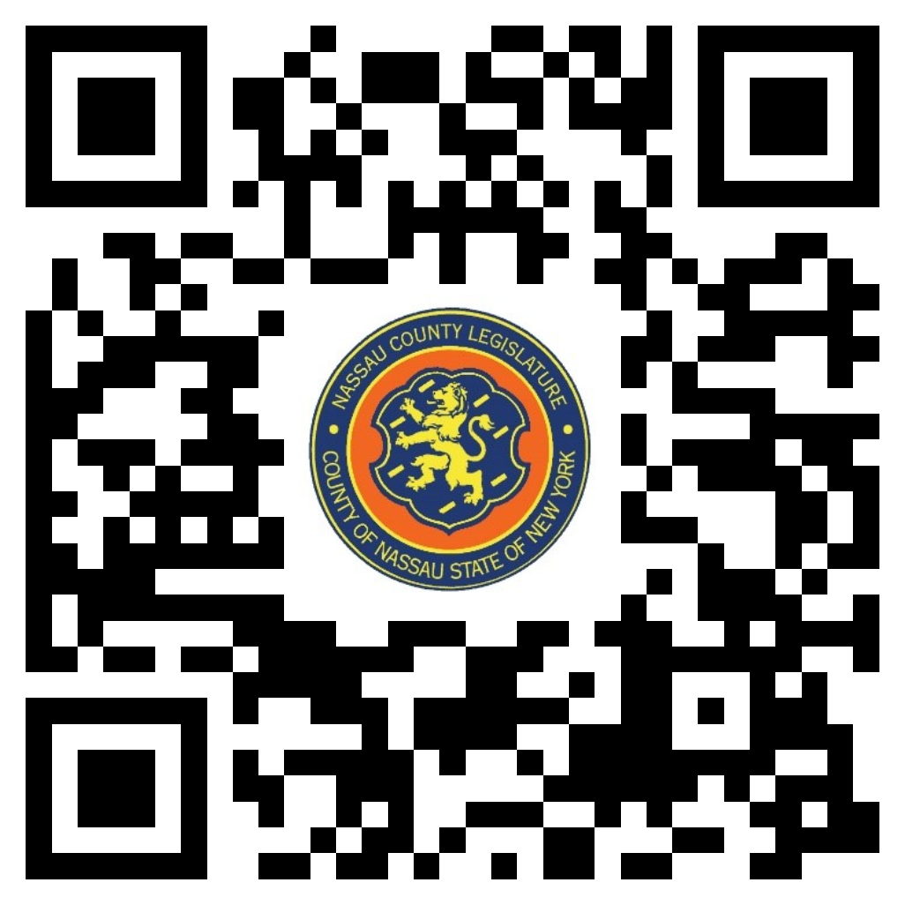

Scan the QR code to submit written public comment,
which will be incorporated into the record of this meeting.

Clerk Item No. | Proposed By | Assigned To | Summary
12-24 | CE | GS, F, R | RESOLUTION NO. – 2024  A RESOLUTION RATIFYING A MEMORANDUM OF AGREEMENT MAKING CERTAIN AMENDMENTS TO THE COLLECTIVE BARGAINING AGREEMENT BETWEEN THE COUNTY OF NASSAU AND NASSAU COMMUNITY COLLEGE, AS JOINT EMPLOYERS, AND THE NASSAU COMMUNITY COLLEGE FEDERATION OF TEACHERS. 12-24(CE)

