NASSAU COUNTY LEGISLATURE

15th TERM MEETING AGENDA
PUBLIC WORKS AND PARKS COMMITTEE
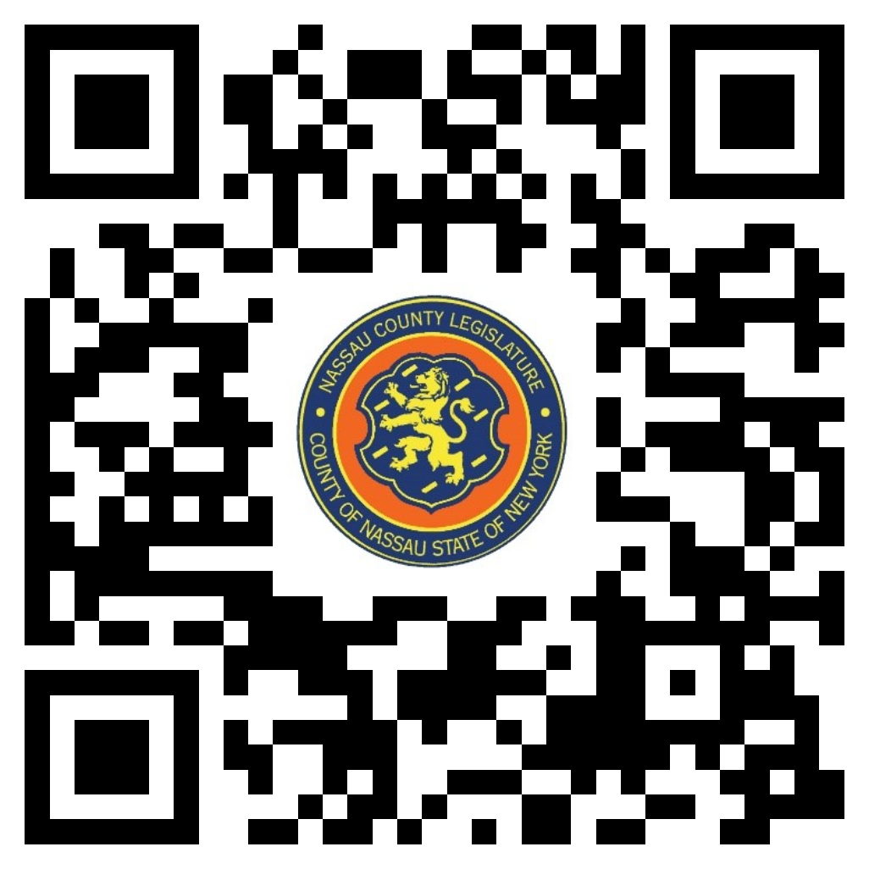MARCH 11, 2024 1:00 PM

Michael Giangregorio - Chairman
John Giuffré - Vice Chairman
James Kennedy
Scott Strauss
Siela A. Bynoe - Ranking
Arnold W. Drucker
Carrié Solages

Michael C. Pulitzer, Clerk of the Legislature

Scan the QR code to submit written public comment,
which will be incorporated into the record of this meeting.

THERE ARE NO ITEMS ON THIS COMMITTEE AT THIS TIME

