NASSAU COUNTY LEGISLATURE
15Th Term Meeting Agenda
VETERANS
COMMITTEE

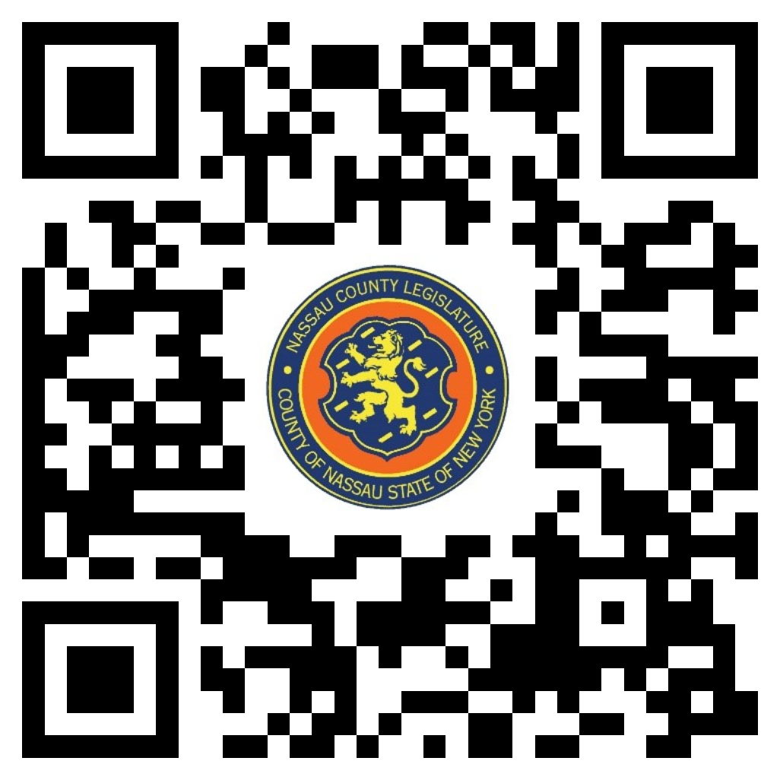MARCH 11, 2024 1:00PM

C. William Gaylor III – Chairman
Rose Marie Walker – Vice Chairwoman
Mazi Melesa Pilip
Patrick Mullaney
Debra Mulé - Ranking
Seth I. Koslow
Scott M. Davis

Michael C. Pulitzer, Clerk of the Legislature

Scan the QR code to submit written public comment,
which will be incorporated into the record of this meeting.

THERE ARE NO ITEMS ON THIS COMMITTEE AT THIS TIME

