NASSAU COUNTY LEGISLATURE
15th TERM MEETING AGENDA
GOVERNMENT SERVICES & OPERATIONS COMMITTEE
MARCH 11, 2024 1:00 PM

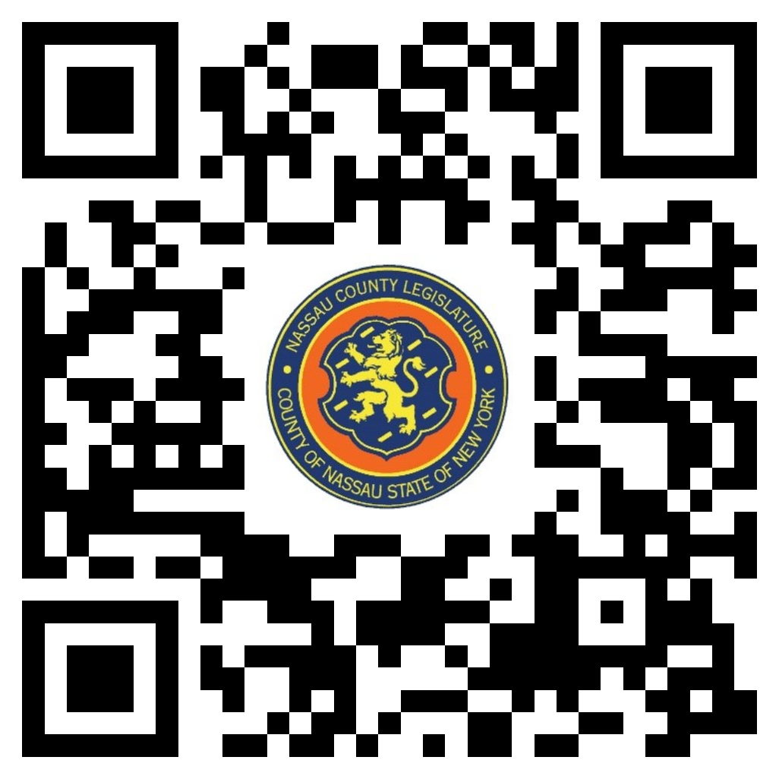

John Ferretti – Chairman
Scott Strauss – Vice Chairman
Michael Giangregorio
John Giuffré
Arnold W. Drucker – Ranking
Carrié Solages
Seth I. Koslow

Michael C. Pulitzer, Clerk of the Legislature

Scan the QR code to submit written public comment,
which will be incorporated into the record of this meeting.

THERE ARE NO ITEMS ON THIS COMMITTEE AT THIS TIME

