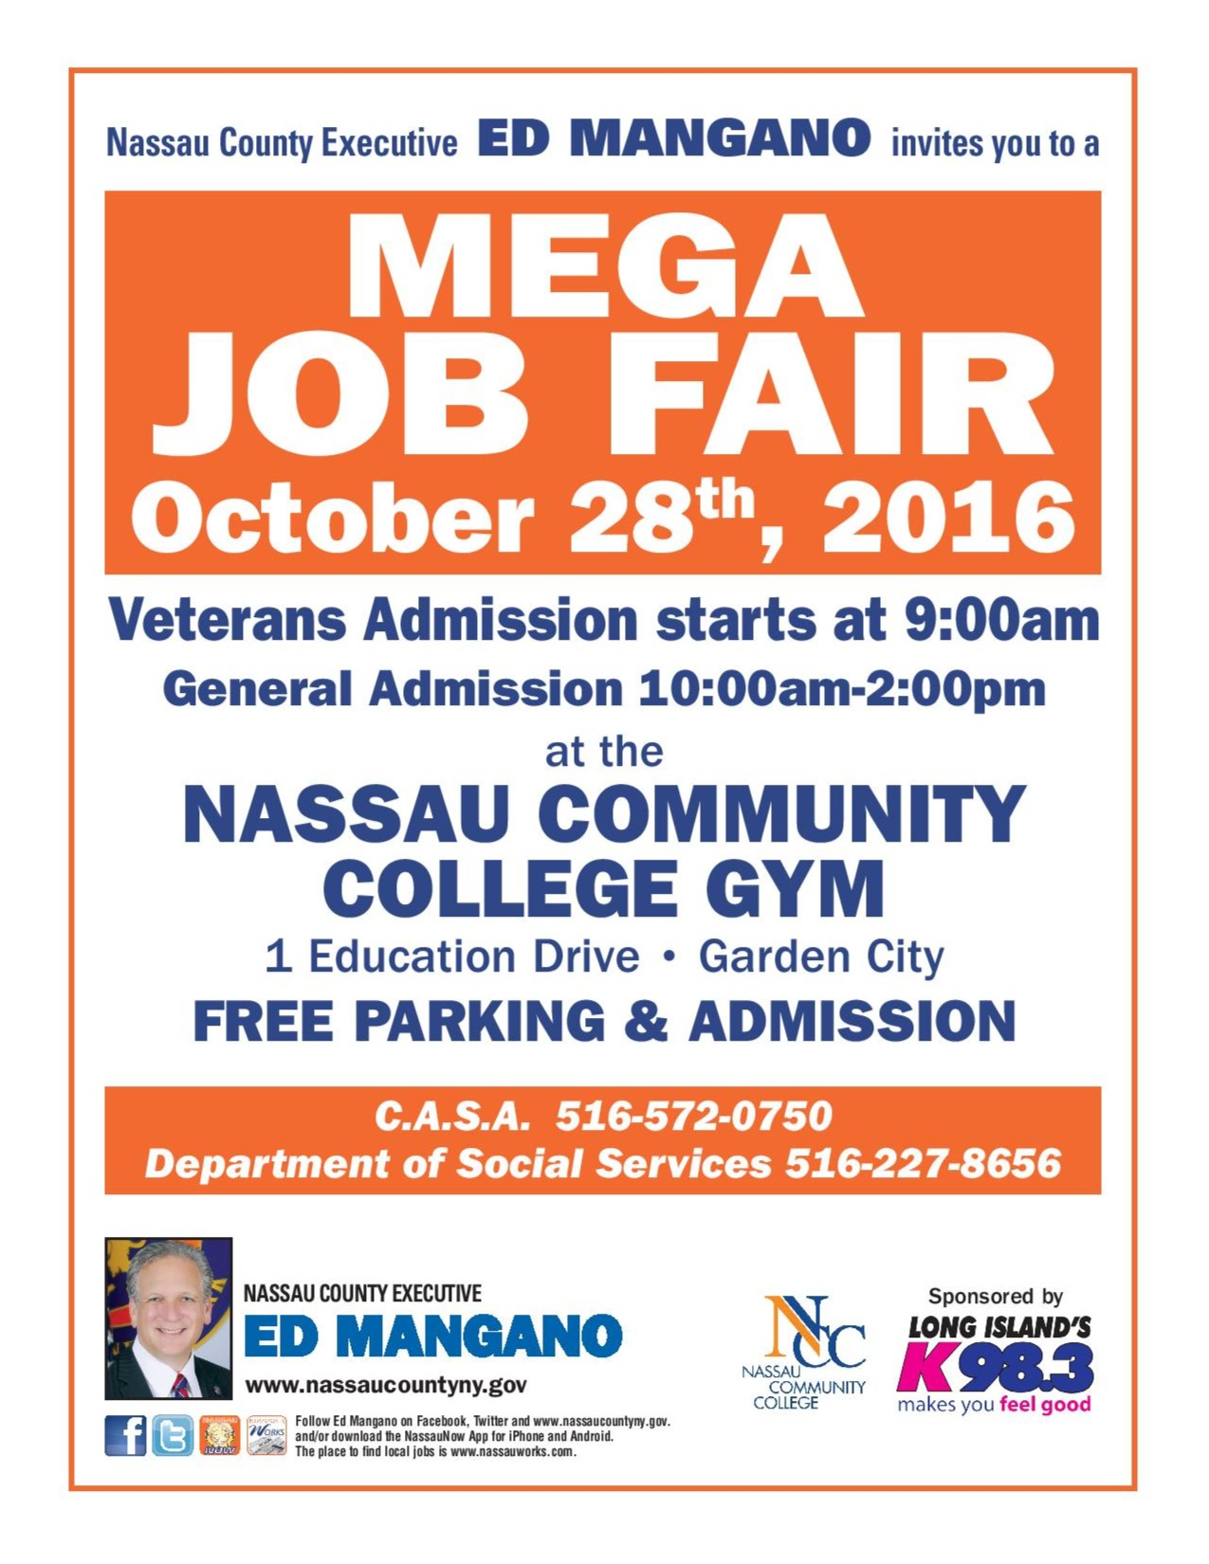

2016 MEGA JOB FAIR

COMPANY INDUSTRY
- 1 800 FLOWERS RETAIL
- 7-Eleven RETAIL
- ABERCROMBIE & RETAIL
FITCH
- ABLE COMMUNITY NON PROFIT
- ABLE HEALTH HOME HEALTH
- ACCES - VR STATE AGENCY
- ACCESS CAREERS VOCATIONAL
- ACCESS STAFFING EMPLOYMENT
- ACCOUNTING EMPLOYMENT
PRINCIPALS/AJILON
- ACDS NON-PROFIT
- ACLD HEALTH CARE
- ADECCO EMPLOYMENT
- ADVANTAGE CARE HEALTH CARE
- AERO SNOW SERVICE
- AEROSOLES RETAIL
- AFFINITY HEALTH INSURANCE
- AFLAC – GARDEN CITY INSURANCE
- AFLAC – JERICHO INSURANCE
- A GENTLE TOUCH HOME CARE
- AGEWELL NY HEALTH CARE
- AHRC NASSAU HEALTH CARE
- AHRC NEW YORK HEALTH CARE
CITY
- AIDES AT HOME HOME HEALTH
- ALL ISLAND TRANSPORTATION
- ALLIED UNIVERSAL SECURITY
- ALLSTATE INSURANCE
- ALTICE(CABLE) TELECOMMUNICATIONS
- AMERICAN EAGLE RETAIL
OUTFITTERS

- AMERICAN WATER WATER UTILITY
WORKS
- AMNEAL MANUFACTORING
PHARM.
- ANN TAYLOR RETAIL
- ARMED FORCES VETERAN AGENCY
SERVICES CORP.
- ARROW SECURITY SECURITY
- ASA COLLEGE EDUCATION
- ASTORIA BANK BANKING
- ATTENTIVE CARE HEALTH CARE
- AUTO CHLOR EQUIPMENT LEASE
SYSTEMS
- AUTOSEUM AUTO . AUTOMOTIVE
TEACHING MUSEUM
- AXA FINANCIAL
- BANANA REPUBLIC RETAIL
- BAYADA HOME HEALTH
- BEST BUY RETAIL
- BEST YET MARKET SUPERMARKET
- B.F.C.U. FINANCIAL
- BETTER HOME HEALTHCARE
- BJG ELECT. DISTR.
ELECTRONICS
- BLUE OCEAN
WEALTH SOLUTIONS FINANCIAL
- BOB’S DISCOUNT
FURNITURE RETAIL
- BR DATA TECH
- BRIGHT STAR HOMECARE
- CA TECHNOLOGIES TECH
- CALIFORNIA PIZZA RESTAURANT
- CAM STAFFING STAFFING – LL
- CANON USA TECH
- CAREER ARC TECH
- CARR TECH
- CATHOLIC CHARITIES NON-PROFIT
- CATHOLIC GUARDIAN NON-PROFIT
SERVICES
- CENTURY 21 RETAIL
- CEREBRAL PALSY HEALTH CARE
ASSOC. OF N.C.
- CERTIFIED LABS BIOTECHNOLOGY
- CHARLOTTE RUSSE RETAIL
- CHEM RX PHARMACY
- CLUB DEMO. SALES
SERVICES
- CN GUIDANCE MENTAL HEALTH
SERVICES
- COLD SPRING RESEARCH
HARBOR
- COLDWELL BANKER REAL ESTATE
RESID. BROKERAGE
- COMFORT KEEPERS HOME CARE
- CONSTRUCTION CONSTRUCTION
EST. SCHOOL
- CONSTRUCTION CONSTRUCTION
FORCE SERVICES
- CORRECT CARE HEALTH CARE
SOLUTIONS
- COX & COMPANY TECH
- CROWN LIFT MATERIAL HANDLING
TRUCKS
- CVS RETAIL
- CYBER TRADING EDUCATION
UNIVERSITY
- DAYTON BROWN TECH
- DEALERTRACK AUTO TECH
- DISPLAY TECH. MERCHANDISING
- DISTRICT COUNCIL 9/ UNION
FTI OF NY
- EC INFOSYSTEMS TECH
- EOC NON-PROFIT
- EOC – RESTORE TO LIFE EX – OFFENDER RE-ENTRY PROGRAM
RE-ENTRY PROGRAM
- EDEN HEALTH CARE
- Egifter TECH
- EDI OPTIONS TECH
- EMPIRE MERCHANTS CONSUMER PRODUCTS
- EVER BANK BANKING
- EVO PAYMENTS INTER. CREDIT/ DEBIT CARD PROCESSING
- FAMILY PEDIATRIC HOME CARE
- FREE HUMAN SERVICES
- FEDEX – GROUND TRANSPORTATION
- FIDELIS HEALTH CARE
- FINISH LINE RETAIL
- FIRST IN SERVICE EMPLOYMENT
STAFFING SOLUT.
- FJC SECURITY SECURITY
- FLUSHING BANK BANKING
- FOREVER 21 RETAIL
GARDEN CITY
- FOREVER 21 RETAIL
HICKSVILLE
- GEICO INSURANCE
- GLCQ, INC INSURANCE
- GLOBAL ELITE SECURITY
- GLOBAL SECURITY AVIATION SECURITY
- GLOBAL THREAT SECURITY
SOLUTIONS
- GREAT ESCAPE HUMAN SERVICES
- G.N.Y.A.D.A. AUTOMOTIVE
- GREEN KEY EMPLOYMENT
- GUARDIAN FINANCIAL*
- GURWIN HOME CARE
- GUTTER HELMET HOME IMPROVEMENT
- H & M RETAIL
- HAMPTON INN HOTEL
- & SUITES
- HAROLD LEVINSON WHOLESALE
ASSOCIATES, LLC DISTRIBUTOR
- HF MANAGEMENT
SERVICES HEALTH
- HILLSIDE VAN LINES TRANSPORTATION
- HOFSTRA UNIVERSITY
- HOLLISTER CO. RETAIL
GARDEN CITY
- HOLLISTER CO. RETAIL
BROADWAY MALL
- HOME CARE HEALTH CARE
AT IT’S BEST
- HOME DEPOT RETAIL
- HONEY BAKED RESTAURANT
HAM
- HORIZON STAFF. EMPLOYMENT
SOLUTIONS
- HUNTER VOCATIONAL
- HYATT PLACE HOTEL
- IKEA RETAIL
- I MOBILE RETAIL
- INNOVEL WAREHOUSE
SOLUTIONS
- J&B REST. RESTAURANT
OF L.I. LLC
- J CREW RETAIL
- JOHN P. PICONE CONSTRUCTION
- JZANUS HOMECARE
- KATE SPADE RETAIL
- KEDRION BIOPHARMA
BIOPHARMA
- KITCHEN MAGIC HOME IMPROVEMENT
- KNIGHTS OF INSURANCE
COLUMBUS
- LIEDTKE MGMT. RESTAURANT
GROUP
- LONG ISLAND CARE VETERAN RESOURCE
VETS WORK PROG.
- LONG ISLAND ADVERTISING
JOB FINDER
- L.I. KIA DEALERS AUTO
- L.I.R.R. TRANSPORTATION
- L.I. TEMPS EMPLOYMENT –SPONSOR
- MANPOWER EMPLOYMENT
- MASSAPEQUA
CAREER CENTER GOVERNMENT
- MASS MUTUAL FINANCIAL
- MAVIS DISCOUNT AUTOMOTIVE
TIRE
- MAXIM HEALTH HEALTH CARE
- MERCY FIRST NON-PROFIT
- MERRY MAIDS HOUSE CLEANING
OF LEVITTOWN
- METRO. CORR. CTR.
FED. BUR. PRISON LAW ENFORCE.
- METRO ONE SECURITY
PREVENTION
- MILLERS RESTAURANT
LEVITTOWN ALE
- MSC TOOL
- MTA TRANSPORTATION
- MUNICIPAL CONSTRUCTION
LAB TESTING
- NADAP NON-PROFIT
- NASSAU COUNTY GOVERNMENT
CLERK
- NASSAU COUNTY GOVERNMENT
HUMAN RIGHTS
- NASSAU COUNTY GOVERNMENT
VETERANS
- N.E.F.C.U. BANKING
- NASSAU VET NON PROFIT
CENTER
- NATIONAL EMPLOYMENT
RECRUIT. GROUP
- NESTLE WATERS BEVERAGE DISTRIBUT.
NORTH AMERICA
- N.Y.C. DEPT. OF
CORRECTION LAW ENFORCEMENT
- N.Y.C. FIRE DEPT. GOVERNMENT
- N.Y.C. TRANSIT TRANSPORTATION
- NEW YORK BANKING
COMMUNITY
- N. Y. HEALTH HOME HEALTH CARE
- N.Y. LIFE INSURANCE
- N.Y. LIFE INSURANCE
- N.Y. NAT. GUARD MILITARY
- N.Y. RISING TEAM II DISASTER RECOVERY
- N.Y. S. DEPT. GOVERNMENT
OF CIVIL SERVICE
- N.Y.S. DEPT. OF GOVERNMENT
LABOR
- N.Y. STATE SOLAR RENEWABLE ENERGY
- N.Y. STATE UNIFIED GOVERNMENT
COURT SYSTEM
- NIKE RETAIL
- NINE WEST RETAIL
- N.T.E.F.W. NON-PROFIT
- NORDSTROM RETAIL
- NORTHWELL HEALTH HEALTH CARE- SPONSOR
VETERAN
- NORTHWESTERN FINANCIAL SERVICES
- ORBIS MEDIA/ MEDIA
A+ STUDENT ADV.
- PANERA FOOD SERVICE
- PEOPLE’S UNITED BANK
- PETRO HOME ENERGY
SERVICES
- PLAZA THEATRICAL ENTERTAINMENT
PRODUCTIONS
- PREFERRED HOME CARE
- PRIMERICA FINANCIAL
- PRINCETON EDUCATION
REVIEW
- PRINCIPLE MERCHANT SERVICES
PAYMENTS
- PROF. PHYSICAL HEALTH CARE
THERAPY
- PROGRESSIVE INSURANCE
- PSCH, INC. MENTAL HEALTH
- QSAC NON-PROFIT
RADIO JOBLINE MEDIA
- RALLYE MOTORS AUTOMOTIVE
- RAY. FLANAGAN RETAIL
FURNITURE
- RELIANCE FIRST FINANCIAL/MORTGAGE
CAPITAL
- RENEGADE RETAIL
- RENEWAL BY HOME IMPROVEMENT
ANDER. WINDOW
- RICHNER COMM. PUBLISHING
- RITE AID PHARMACY
- RIVERHEAD BUILD. RETAIL/BUILD. MATERIALS
SUPPLY
- RUE 21 RETAIL
- SAFE HAVEN HUMAN SERVICES
- S.A.I.L. HOUSING AGENCY
- SARA HEALTHCARE
COMPANION
- SBDC VETERAN AGENCY
- SCO HUMAN SERVICE
- SCOPE CHILD CARE
- SEARS RETAIL

- SECURITY SECURITY
ENFORCE.
- SELF HELP HOME CARE
COMM. SERV.
- SELL TO A VET. REAL ESTATE
- SEMPER 4 VET. NON-PROFIT
- SENIOR HELPERS HOME CARE
- SNOWLIFT LLC. SNOW REMOVAL
- SOUTH NASSAU HOSPITAL
COMMUNITIES
- STAR GAS ENERGY
PARTNERS
- STELLAE SHIPPING
INTER.
- STERICYCLE MEDICAL
- SUMMIT HOME CARE
- SUNRISE CAREER HOME INSPECTION-
INSTITUTE SOLAR ENERGY
- SUSTAIN. SOLAR
RENEW. ENTER.
- TARGET RETAIL
HAUPPAGUE
- TARGET RETAIL
HUNTINGTON
- TEACHERS F.C.U. FINANCIAL SERVICES
- THE CENTER FOR
DEV. DIS. HUMAN SERVICES
- THE CENTER FOR HUMAN SERVICES
FAMILY SUPPORT
- THE CORAL HOUSE/ CATERING
MILLERIDGE INN
- THE LGBT NETWORK NOT FOR PROFIT
- THE TOWN OF GOVERNMENT
NO. HEMPSTEAD
- THE VISCARDI NON PROFIT
CENTER
- T.O. H. GOVERNMENT
- TRANSDEV TRANSPORTATION
NICE
- TRANSITIONAL HOUSING
SERVICES OF NY

- TRI BUS. & CAREER NONPROFIT
TRAINING CENTER
- TRUE EARTH MARKETING
HEALTH PRODUCTS
- TUTOR TIME CHILD CARE
- ULTIMATE CLASS TRANSPORTATION
LIMO
- UNITED HEALTHCARE HEALTH CARE
- UNCLE GIUSEPPE’S SUPERMARKET
MARKET PLACE
- U.S. ARMY MILITARY
- U.S. CUSTOMS &
BORDER PROTECT. FEDERAL LAW ENFORCE.
- U.S. DEPT. OF
VETERAN AFFAIRS HEALTHCARE
- U.S. DYNAMICS MANUFACTURING
- U.S. NAVY MILITARY
- U.S. POSTAL MAIL
SERVICE
- UNITED VET. VETERAN SERVICES
BEACON HOUSE
- UPS PACKAGE
- UTOPIA
KINGS PARK HEALTH CARE
- UTOPIA
WESTBURY HEALTH CARE
- VALUCARE, INC HOME HEALTH
- VANILLA SKY RETAIL
- VICTORIA’S RETAIL
SECRET
- VIP AUTOMOTIVE
- VISIONWORKS OPTICAL
- VOLT PAYMENTS MERCHANT SERVICES
- VSP GLOBAL/ FASHION
MARCHON EYE.
- WE’RE ASSOC. REAL ESTATE
- WHOLE FOODS GROCERY
- WINDOWRAMA HOME IMPROVE.
- WINSTON EMPLOYMENT
- WINTHROP HEALTH CARE

- WORLD GYM FITNESS
EAST MEADOW
- YAI SOCIAL SERVICES
- YANKEE CANDLE RETAIL

*Check that they have salary positions or willing to be sponsors.
WL – waiting list –Donor – monies under $1,000 – Sponsor - monies $1,000 or more

