NASSAU COUNTY LEGISLATURE
14th TERM MEETING AGENDA
PUBLIC SAFETY COMMITTEE
MAY 8, 2023 1:00 PM

Denise Ford - Chairwoman
- Vice Chairman
Mazi Melesa Pilip
John Ferretti
Delia Deriggi-Whitton - Ranking
Siela Bynoe
Debra Mulé

Michael C. Pulitzer, Clerk of the Legislature

Scan the QR code to submit written public comment,
which will be incorporated into the record of this meeting.
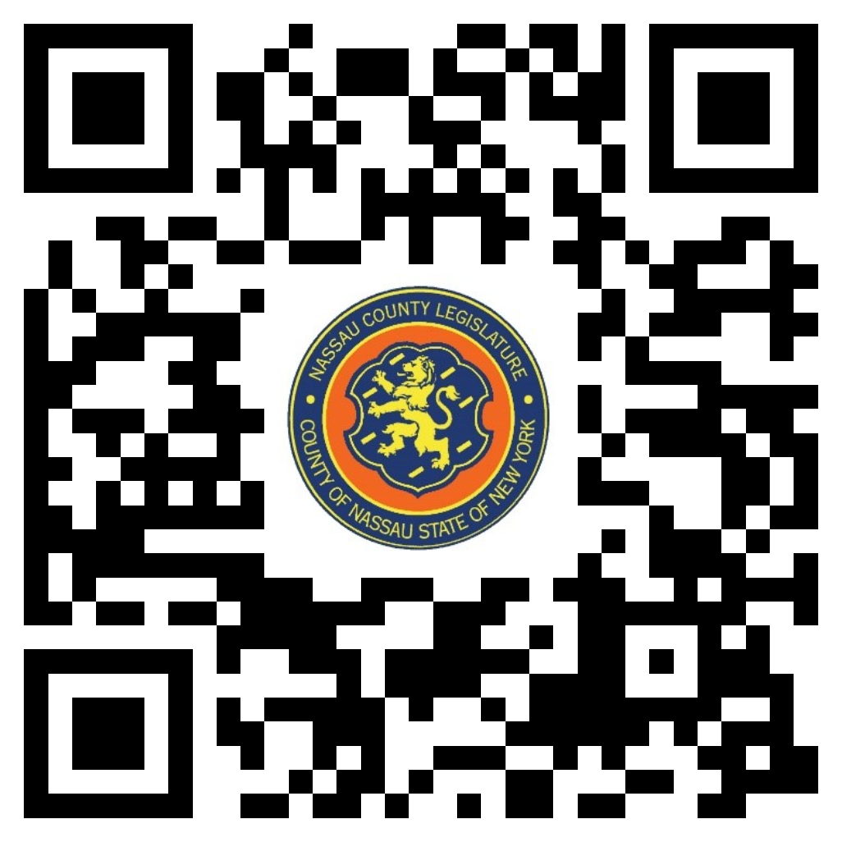
Clerk Item No. |  | Proposed By | Assigned To | Summary
 | 159-23 | OMB | PS, F, R | ORDINANCE NO. – 2023  AN ORDINANCE SUPPLEMENTAL TO THE ANNUAL APPROPRIATION ORDINANCE IN CONNECTION WITH THE NASSAU COUNTY OFFICE OF CRIME VICTIM ADVOCATE. 159-23(BU)
 | 162-23 | OMB | PS, F, R | ORDINANCE NO. – 2023  AN ORDINANCE SUPPLEMENTAL TO THE ANNUAL APPROPRIATION ORDINANCE IN CONNECTION WITH THE OFFICE OF THE DISTRICT ATTORNEY. 162-23(OMB)
 | 163-23 | OMB | PS, F, R | ORDINANCE NO. – 2023  AN ORDINANCE SUPPLEMENTAL TO THE ANNUAL APPROPRIATION ORDINANCE IN CONNECTION WITH THE TRAFFIC SAFETY BOARD. 163-23(OMB)

