NASSAU COUNTY LEGISLATURE
14th TERM MEETING AGENDA
TOWNS, VILLAGES & CITIES
COMMITTEE
MAY 8, 2023 1:00 PM

Mazi Melesa Pilip – Chairwoman
Laura Schaefer – Vice Chairwoman
James Kennedy
C. William Gaylor III
Joshua Lafazan – Ranking
Debra Mulé
Delia DeRiggi-Whitton

Michael C. Pulitzer, Clerk of the Legislature

Scan the QR code to submit written public comment,
which will be incorporated into the record of this meeting.
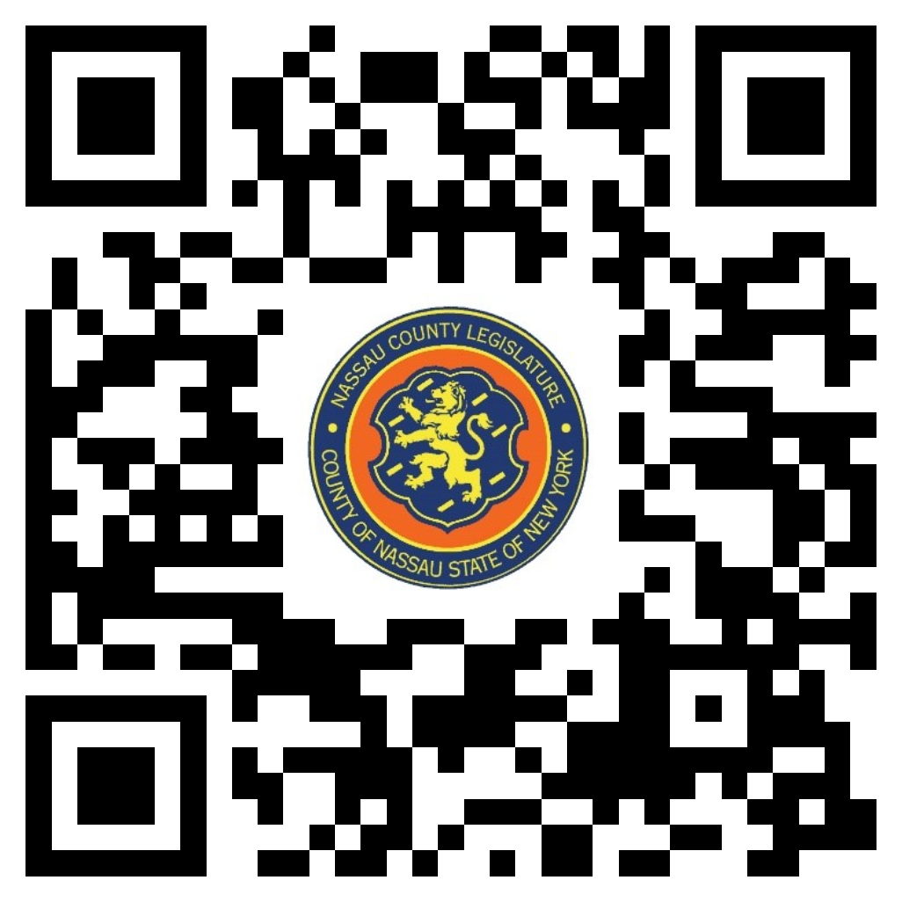

THERE ARE NO ITEMS ON THIS COMMITTEE AT THIS TIME

