NASSAU COUNTY LEGISLATURE
14th TERM MEETING AGENDA
GOVERNMENT SERVICES & OPERATIONS COMMITTEE
MAY 8, 2023 1:00 PM

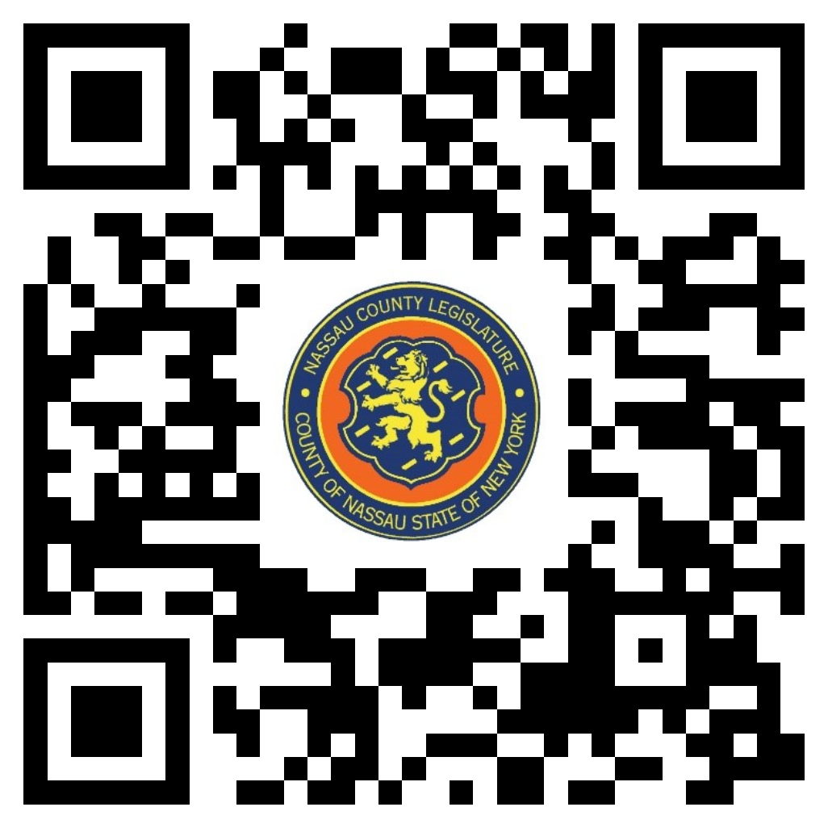John Ferretti – Chairman
Denise Ford – Vice Chairwoman
Tom McKevitt
John Giuffré
Arnold Drucker – Ranking
Joshua Lafazan
Carrié Solages

Michael C. Pulitzer, Clerk of the Legislature

Scan the QR code to submit written public comment,
which will be incorporated into the record of this meeting.

THERE ARE NO ITEMS ON THIS COMMITTEE AT THIS TIME

