NASSAU COUNTY LEGISLATURE
14th TERM MEETING AGENDA
ECONOMIC AND COMMUNITY
DEVELOPMENT, LABOR AND TRANSPORTATION COMMITTEE
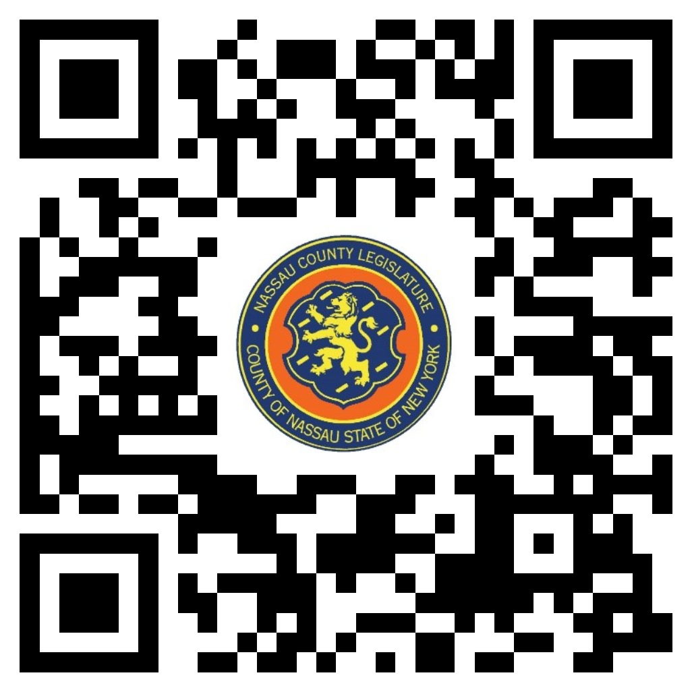
MAY 8, 2023 1:00 PM

Tom McKevitt, Chairman
James Kennedy, Vice Chairman
C. William Gaylor III
Denise Ford
Siela Bynoe, Ranking
Debra Mulé
Arnold Drucker

Michael C. Pulitzer, Clerk of the Legislature

Scan the QR code to submit written public comment,
which will be incorporated into the record of this meeting.

THERE ARE NO ITEMS ON THIS COMMITTEE AT THIS TIME

