NASSAU COUNTY LEGISLATURE
14th TERM MEETING AGENDA
MINORITY AFFAIRS COMMITTEE

MAY 8, 2023 1:00 PM

– Chairman
Rose Marie Walker – Vice Chairwoman
James Kennedy
Denise Ford
Carrié Solages – Ranking
Kevan Abrahams
Debra Mulé

Michael C. Pulitzer, Clerk of the Legislature

Scan the QR code to submit written public comment,
which will be incorporated into the record of this meeting.
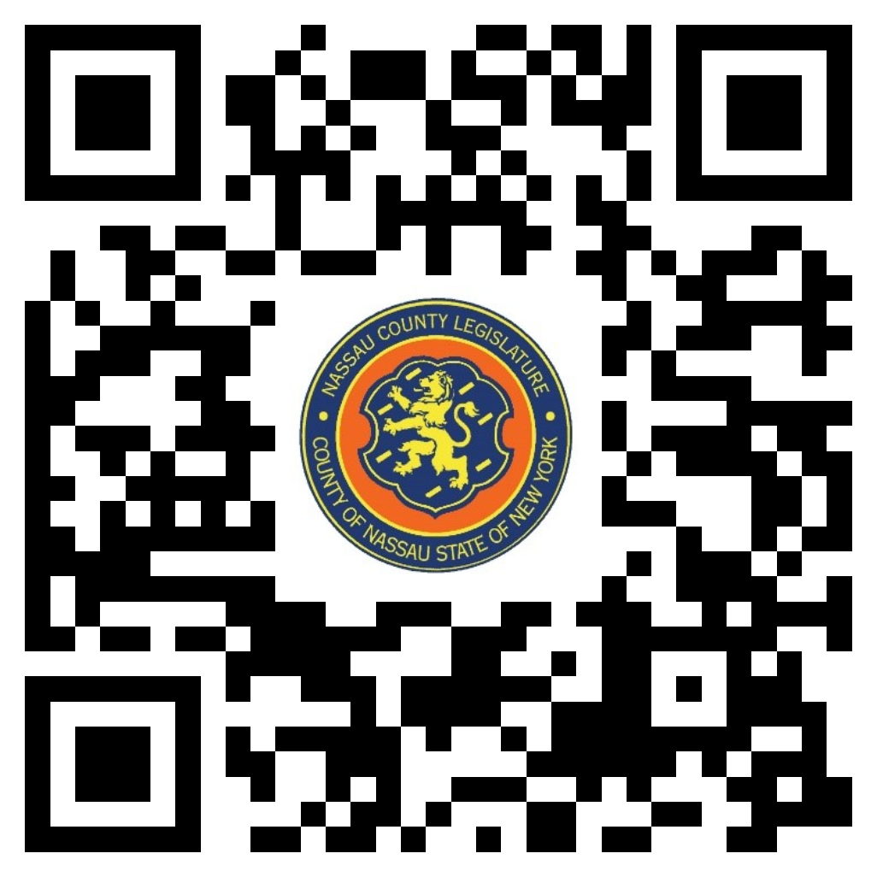

THERE ARE NO ITEMS ON THIS COMMITTEE AT THIS TIME

