NASSAU COUNTY LEGISLATURE
14Th Term Meeting Agenda
SENIOR AFFAIRS
COMMITTEE

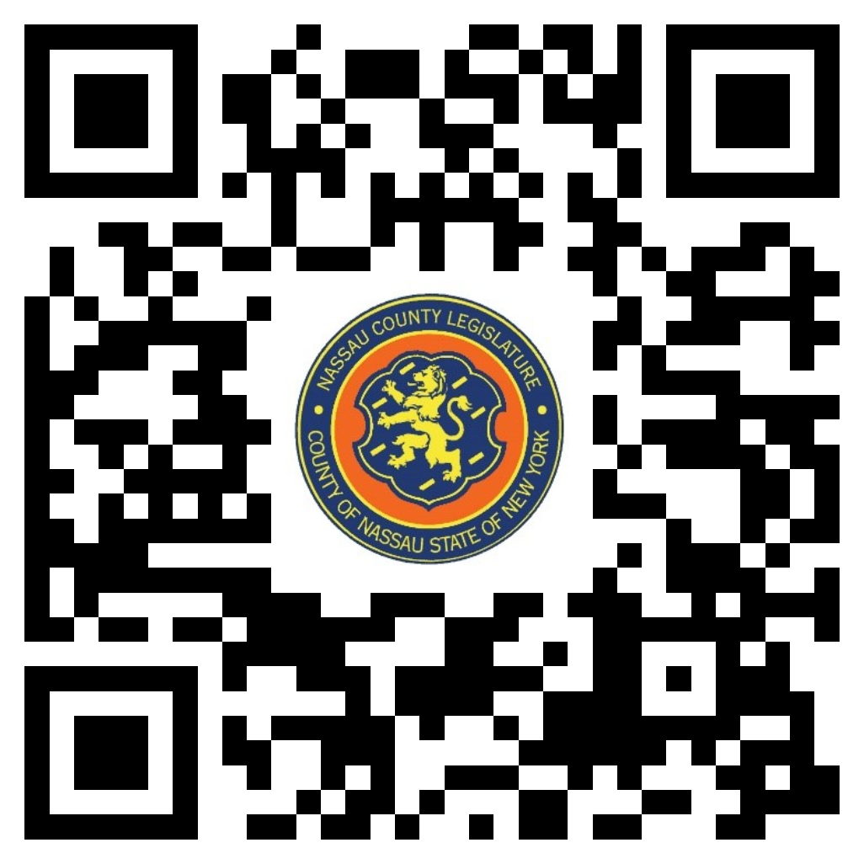MAY 8, 2023 1:00 PM

John Giuffré – Chairman
Rose Marie Walker – Vice Chairwoman
Tom McKevitt
Maza Melesa Pilip
Debra Mulé- Ranking
Delia DeRiggi-Whitton
Joshua Lafazan

Michael C. Pulitzer, Clerk of the Legislature

Scan the QR code to submit written public comment,
which will be incorporated into the record of this meeting.

THERE ARE NO ITEMS ON THIS COMMITTEE AT THIS TIME

