NASSAU COUNTY LEGISLATURE
14th TERM MEETING AGENDA

HEALTH AND SOCIAL SERVICES COMMITTEE
MAY 8, 2023 1:00 PM
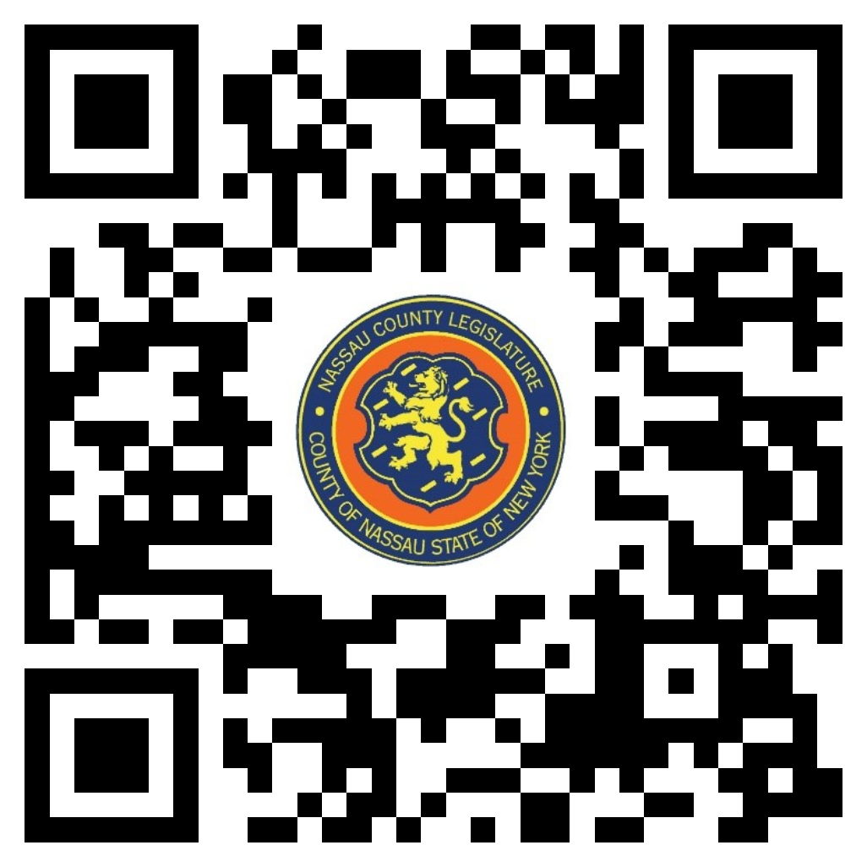
Rose Marie Walker – Chairwoman
Mazi Melesa Pilip – Vice Chairwoman
Laura Schaefer
C. William Gaylor III
Delia DeRiggi-Whitton – Ranking
Arnold Drucker
Joshua Lafazan

Michael C. Pulitzer, Clerk of the Legislature

Scan the QR code to submit written public comment,
which will be incorporated into the record of this meeting.

Clerk Item  No. | Proposed By | Assigned To | Summary
147-23 | HE | H, R | RESOLUTION NO. – 2023  A RESOLUTION AUTHORIZING THE COUNTY EXECUTIVE TO EXECUTE AN INTER-GOVERNMENTAL AGREEMENT BETWEEN THE COUNTY OF NASSAU, ACTING ON BEHALF OF THE NASSAU COUNTY DEPARTMENT OF HEALTH AND VARIOUS AGENCIES (“NASSAU COUNTY”), AND SUFFOLK COUNTY, ACTING ON BEHALF OF THE SUFFOLK COUNTY DEPARTMENT OF HEALTH SERVICES (“SUFFOLK COUNTY”). 147-23(HE)
165-23 | OMB | H, F, R | ORDINANCE NO. – 2023  AN ORDINANCE SUPPLEMENTAL TO THE ANNUAL APPROPRIATION ORDINANCE IN CONNECTION WITH THE HEALTH DEPARTMENT. 165-23(OMB)

