NASSAU COUNTY LEGISLATURE
15th TERM MEETING AGENDA
RULES COMMITTEE ADDENDUM
JANUARY 8, 2024 1:00 PM

Scan the QR code to submit written public comment,
which will be incorporated into the record of this meeting.

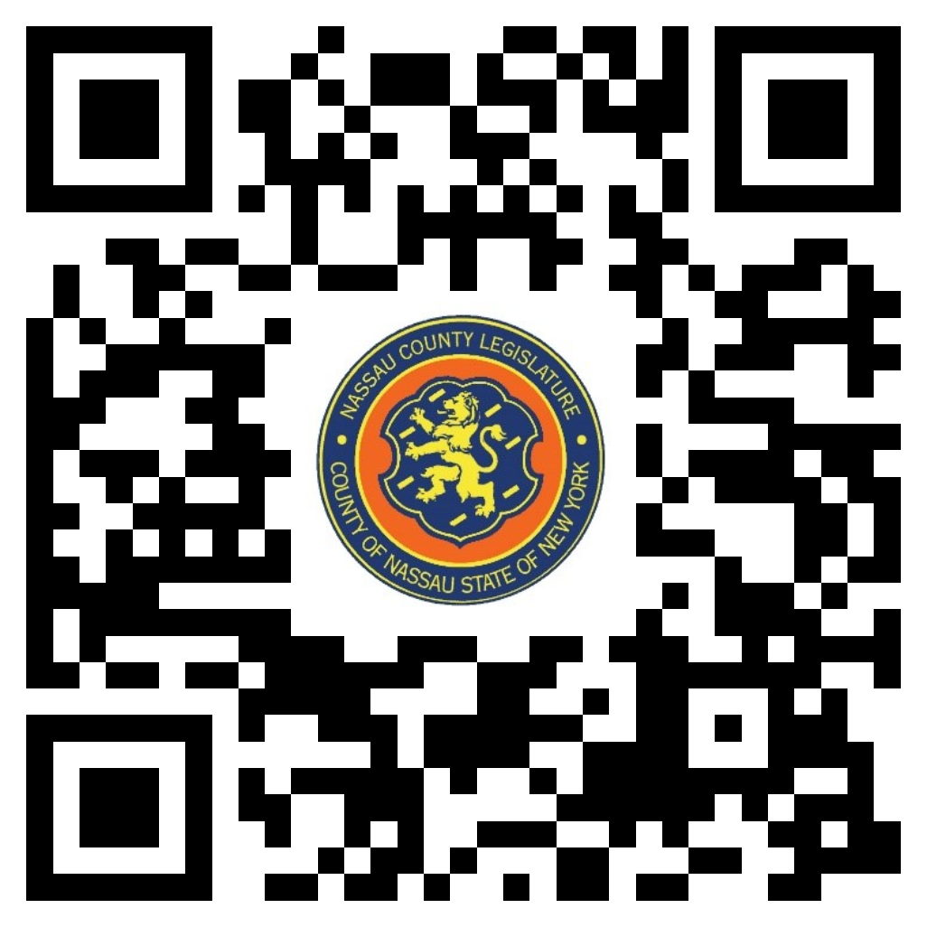

Clerk Item No. | Proposed By | Assigned To | Summary
8-24 | OMB | PS, F, R | ORDINANCE NO. – 2024  AN ORDINANCE SUPPLEMENTAL TO AN APPROPRIATION ORDINANCE IN CONNECTION WITH TRAFFIC SAFETY BOARD. 8-24(OMB)
9-24 | OMB | H, F, R | ORDINANCE NO. – 2024  AN ORDINANCE SUPPLEMENTAL TO AN APPROPRIATION ORDINANCE IN CONNECTION WITH THE HEALTH DEPARTMENT. 9-24(OMB)
10-24 | OMB | PS, F, R | ORDINANCE NO. – 2024  AN ORDINANCE SUPPLEMENTAL TO AN APPROPRIATION ORDINANCE IN CONNECTION WITH THE MEDICAL EXAMINER. 10-24(OMB)
11-24 | OMB | PS, F, R | ORDINANCE NO. – 2024  AN ORDINANCE SUPPLEMENTAL TO AN APPROPRIATION ORDINANCE IN CONNECTION WITH THE OFFICE OF EMERGENCY MANAGEMENT. 11-24(OMB)
12-24 | CE | R | RESOLUTION NO. – 2024  A RESOLUTION RATIFYING A MEMORANDUM OF AGREEMENT MAKING CERTAIN AMENDMENTS TO THE COLLECTIVE BARGAINING AGREEMENT BETWEEN THE COUNTY OF NASSAU AND NASSAU COMMUNITY COLLEGE, AS JOINT EMPLOYERS, AND THE NASSAU COMMUNITY COLLEGE FEDERATION OF TEACHERS. 12-24(CE)

