NASSAU COUNTY LEGISLATURE
15th TERM MEETING AGENDA
PUBLIC SAFETY COMMITTEE
FEBRUARY 5, 2024 1:00 PM

Patrick Mullaney - Chairman
Scott Strauss -Vice Chairman
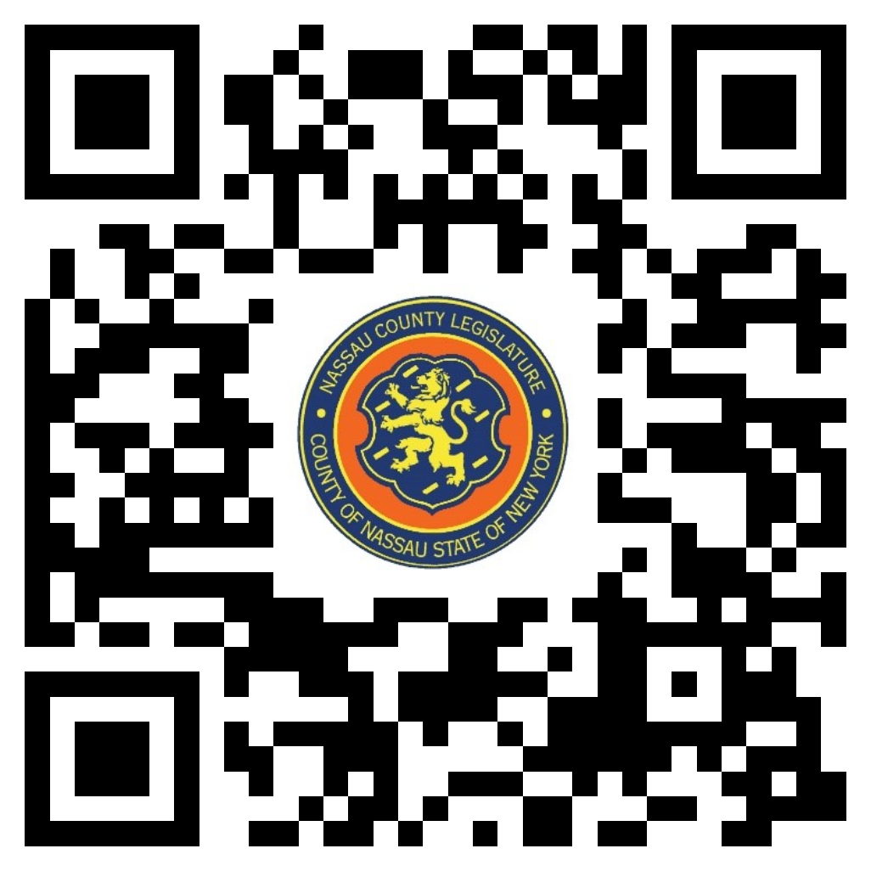Mazi Melesa Pilip
John Ferretti
Siela A. Bynoe - Ranking
Debra Mulé
Scott M. Davis

Michael C. Pulitzer, Clerk of the Legislature

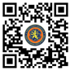Scan the QR code to submit written public comment,
which will be incorporated into the record of this meeting.
Clerk Item No. |  | Proposed By | Assigned To | Summary
 | 15-24 | OMB | PS, F, R | ORDINANCE NO. – 2024  AN ORDINANCE SUPPLEMENTAL TO THE ANNUAL APPROPRIATION ORDINANCE IN CONNECTION WITH THE NASSAU COUNTY OFFICE OF CRIME VICTIM ADVOCATE. 15-24(OMB)
 | 16-24 | OMB | PS, F, R | ORDINANCE NO. – 2024  AN ORDINANCE SUPPLEMENTAL TO THE ANNUAL APPROPRIATION ORDINANCE IN CONNECTION WITH THE PROBATION DEPARTMENT. 16-24(OMB
 | 25-24 | OMB | PS, F, R | ORDINANCE NO. – 2024  AN ORDINANCE SUPPLEMENTAL TO THE ANNUAL APPROPRIATION ORDINANCE IN CONNECTION WITH THE PROBATION DEPARTMENT. 25-24(OMB)

