NASSAU COUNTY LEGISLATURE
15th TERM MEETING AGENDA

HEALTH AND SOCIAL SERVICES COMMITTEE
FEBRUARY 5, 2024 1:00 PM
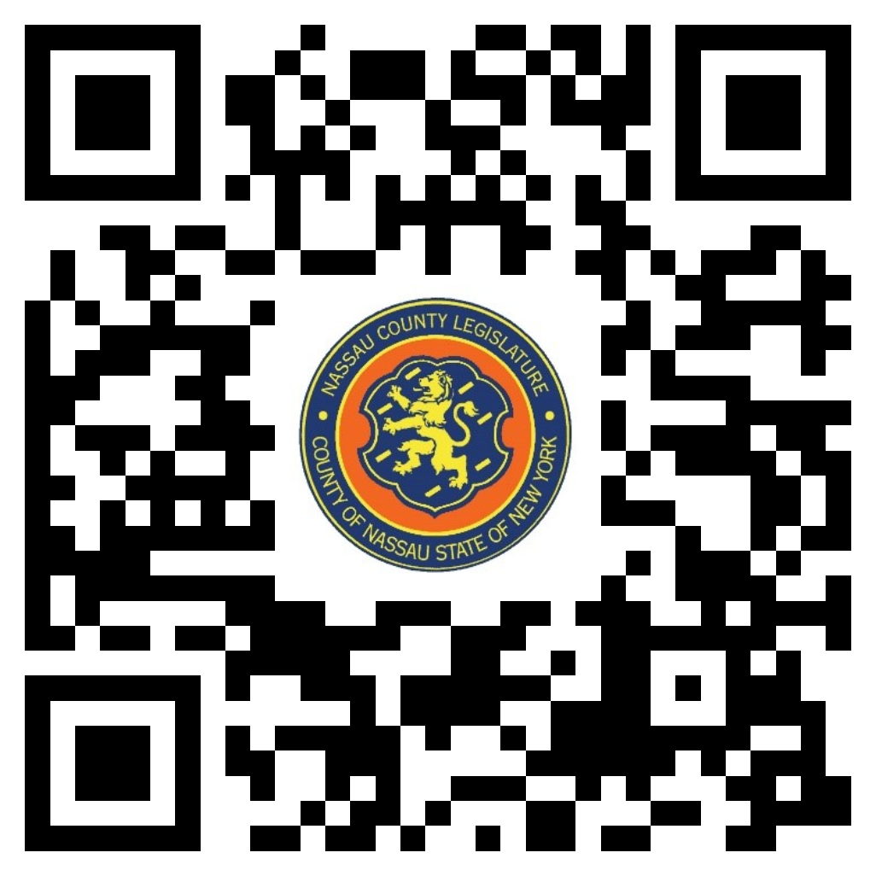
Rose Marie Walker – Chairwoman
Michael Giangregorio – Vice Chairman
Mazi Melesa Pilip
Samantha Goetz
Delia DeRiggi -Whitton – Ranking
Arnold W. Drucker
Seth I. Koslow

Michael C. Pulitzer, Clerk of the Legislature

Scan the QR code to submit written public comment,
which will be incorporated into the record of this meeting.

Clerk Item  No. | Proposed By | Assigned To | Summary
22-24 | OMB | H, F, R | ORDINANCE NO. – 2024  AN ORDINANCE SUPPLEMENTAL TO THE ANNUAL APPROPRIATION ORDINANCE IN CONNECTION WITH THE HEALTH DEPARTMENT. 22-24(OMB)

