NASSAU COUNTY LEGISLATURE
15Th Term Meeting Agenda
SENIOR AFFAIRS
COMMITTEE

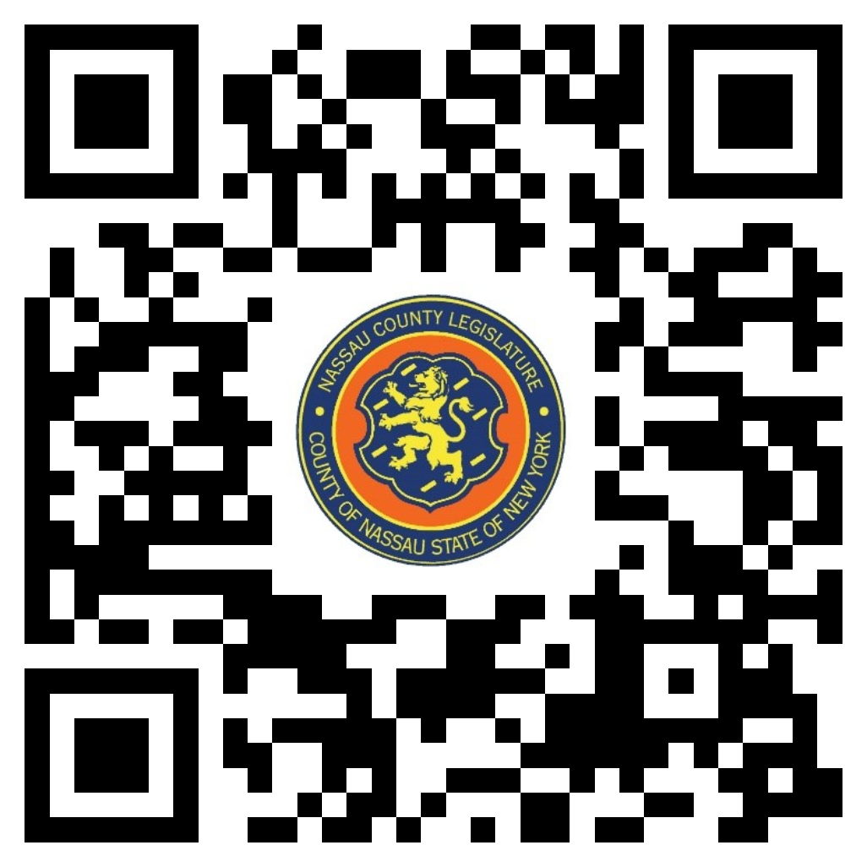FEBRUARY 5, 2024 1:00 PM

John Giuffré – Chairman
Rose Marie Walker – Vice Chairwoman
Thomas McKevitt
Patrick Mullaney
Debra Mulé- Ranking
Delia DeRiggi-Whitton
Scott M. Davis

Michael C. Pulitzer, Clerk of the Legislature

Scan the QR code to submit written public comment,
which will be incorporated into the record of this meeting.

THERE ARE NO ITEMS ON THIS COMMITTEE AT THIS TIME

