NASSAU COUNTY LEGISLATURE
15th TERM MEETING AGENDA
TOWNS, VILLAGES & CITIES
COMMITTEE
MARCH 11, 2024 1:00 PM
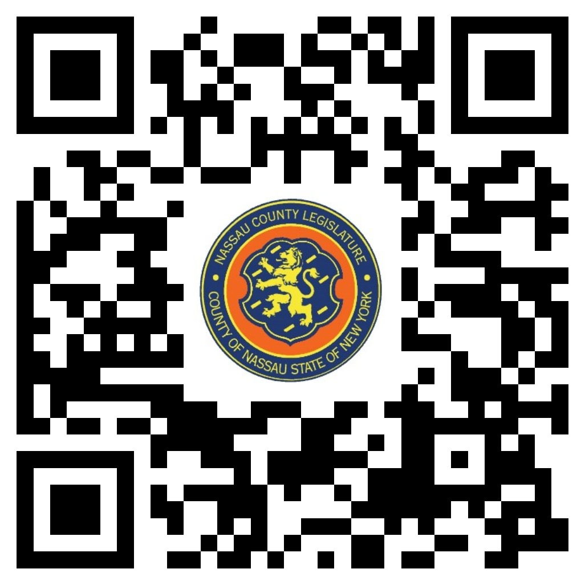

Mazi Melesa Pilip – Chairwoman
C. William Gaylor III – Vice Chairman
Samantha Goetz
Scott Strauss
Debra Mulé – Ranking
Seth I. Koslow
Scott M. Davis

Michael C. Pulitzer, Clerk of the Legislature

Scan the QR code to submit written public comment,
which will be incorporated into the record of this meeting.

Clerk Item No. | Proposed By | Assigned To | Summary
50-24 | OMB | TV, F, R | ORDINANCE NO. – 2024  AN ORDINANCE TO IMPLEMENT THE LOCAL GOVERNMENT ASSISTANCE PROGRAM IN NASSAU COUNTY. 50-24(OMB)

