NASSAU COUNTY LEGISLATURE
15th TERM MEETING AGENDA
ECONOMIC AND COMMUNITY
DEVELOPMENT, LABOR AND TRANSPORTATION COMMITTEE
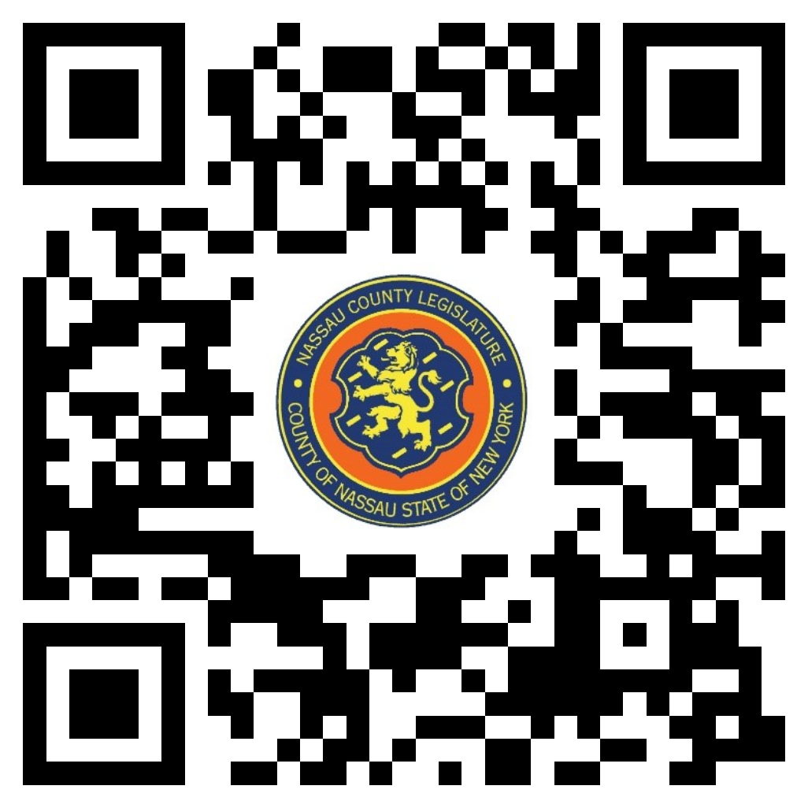
MARCH 11, 2024 1:00 PM

James Kennedy - Chairman
Thomas McKevitt - Vice Chairman
C. William Gaylor III
Samantha Goetz
Siela A. Bynoe, Ranking
Debra Mulé
Arnold W. Drucker

Michael C. Pulitzer, Clerk of the Legislature

Scan the QR code to submit written public comment,
which will be incorporated into the record of this meeting.

THERE ARE NO ITEMS ON THIS COMMITTEE AT THIS TIME

