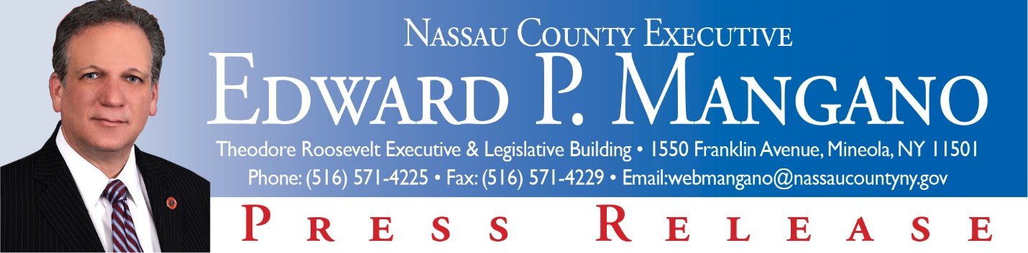

For Immediate Release: March, 2015
Contact: Katie Grilli-Robles, Press Secretary (516) 571-4225

Mangano Announces the 2015 Long Island Community and Economic Development Conference

Mineola, NY- Nassau County Executive Edward P. Mangano and the Nassau County Office of Minority Affairs in collaboration with the New Millennium Development and the State University of New York today announced the 2015 Long Island Community and Economic Development Conference to take place on September 24th, from 8:00 a.m. to 5:00 p.m. at the Crest Hollow Country Club located in Woodbury.

The conference will produce the Largest Procurement Conference on Long Island. The conferences provides an excellent business networking forum for Nassau County vendors and contractors. This forum will facilitate educational workshops and networking for conference attendees with contract decision-makers from governmental agencies, major corporations, educational institutions and nonprofit organizations.

County Executive Mangano stated, “By facilitating the largest MWBE Regional Outreach Event on Long Island, the 2015 Long Island Community and Economic Development Conference provides a great opportunity for my administration to continue our commitment of enhancing Minority, Women, Veteran and Small Business participation and development throughout Nassau County.”

The conference will bring together thousands of businesses including Minority & Women Owned Businesses, Veteran- Owned Firms, Small Businesses, and Disadvantaged Business Enterprises from the public and private sector. The event will consist of plenary sessions, workshops, luncheon with featured speakers and the business pavilion exhibition hall. There will also be a business matchmaking session that facilitates 2 hours of 10 minute intervals of one-on-one meetings for major buyers and suppliers.

The conference will be held at the Crest Hollow Country Club in Woodbury from 8:00 a.m. - 5:00 p.m. For additional information on the conference, please contact Nassau County’s MWBE Regional Event Planner, Tonya Lewter-Gordon at (516) 223-3855 or by email: nwmillennium@optonline.net.

###

