# Andreatta: Amy Menz deserves stiffer hit-and-run laws

**http://www.gannett-cdn.com/-mm-/0e71720e8d65b7ff1a71e5f18dba03d4ca3ada45/c=150-3-494-347&r=1024x1024&r=26&c=26x26/local/-/media/Rochester/USATODAY/2014/07/15/1405454999000-daveandreattanew.jpg David Andreatta, Staff writer***11:24 a.m. EDT October 17, 2014*

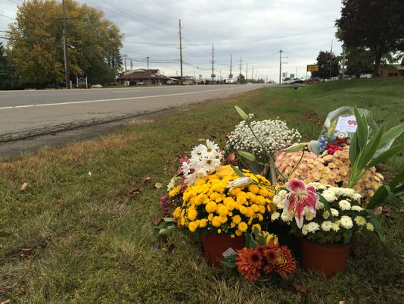Buy Photo

*(Photo: Victoria E. Freile/@vfreile , Staff photographer )*

 17**CONNECT**[19**TWEET**](https://twitter.com/intent/tweet?url=http%3A//on.rocne.ws/1waIQ22&text=Andreatta%3A%20Amy%20Menz%20deserves%20stiffer%20hit-and-run%20laws&via=DandC)[**LINKEDIN**](http://www.linkedin.com/shareArticle?url=http%3A//on.rocne.ws/1waIQ22&mini=true) 1**COMMENTEMAILMORE**

The hit-and-run drivers [who killed 30-year-old Amy Menz in Penfield last week](http://www.democratandchronicle.com/story/news/2014/10/13/many-questions-remain-fatal-hit-run/17203917/) are still at large.

How do they live with themselves? Do they go to work every day like nothing happened? Are they gabbing at the coffee shop about what a shame it all is?

There are lots of reasons drivers flee an accident, but prosecutors and investigators say the most common is that the drivers were drunk.

Authorities haven't given any indication that drugs or alcohol were involved here. Then again, authorities really don't know because the drivers and the passengers they may have been carrying vanished into the night.

**More:**[Columns by David Andreatta](http://www.democratandchronicle.com/topic/84175419-52f7-481f-9248-cf14a864130f/david-andreatta/)

Not infrequently, hit-and-run offenders surrender after sobering up and spill some cockamamie story about how they thought they had hit a raccoon until they saw the tragedy on the 11 o'clock news and put two-and-two together.

Their excuses don't add up, and neither do state laws that give drivers an incentive to flee.

For instance, a drunken driver involved in a fatal crash could face a charge of aggravated vehicular homicide, a class B felony punishable by up to 25 years in prison.

[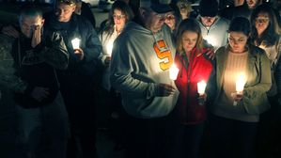](http://www.democratandchronicle.com/story/news/2014/10/15/amy-menz-vigil-penfield/17336841/?from=global&sessionKey=&autologin=)

[DEMOCRATANDCHRONICLE](http://www.democratandchronicle.com/story/news/2014/10/15/amy-menz-vigil-penfield/17336841/?from=global&sessionKey=&autologin=)

[Hit-and-run victim remembered at vigil](http://www.democratandchronicle.com/story/news/2014/10/15/amy-menz-vigil-penfield/17336841/?from=global&sessionKey=&autologin=)

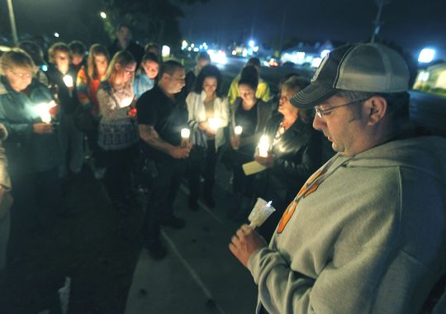

**Amy's brother, Matt Menz, right, holds a candle during a vigil to remember her on Wednesday night.***(Photo: CARLOS ORTIZ/@cfortiz_dandc, STAFF PHOTOGRAPHER)*

But if the same driver flees, he's typically charged with leaving the scene of an accident that results in death without reporting, a class D felony punishable by up to 7 years, because it's virtually impossible for prosecutors to prove he was drunk.

The disparity infuriates Assemblyman David Gantt, a Rochester Democrat who has twice introduced a bill to upgrade hit-and-runs that kill or maim to C felonies, which carry a maximum 15-year prison term.

"The people who do this have got to take responsibility," said Gantt, who plans to introduce the bill a third time when the new legislative session begins in January.

On Long Island this week, Nassau County District Attorney Kathleen Rice renewed her calls for tougher penalties when a retired police officer was sentenced to 2 1/3 to 7 years in a hit-and-run that killed 13-year-old Bryanna Soplin in June.

"The law needs to change to discourage drivers from fleeing in the first place," Rice said. "Right now, a driver may face lower charges because he has prevented a full investigation."

The former officer, Michael Elardo, contacted police 10 hours after the accident claiming he thought Bryanna was a traffic cone.

A traffic cone? I don't buy it.

**Saturday night:**[Woman struck, killed on Empire Boulevard](http://www.democratandchronicle.com/story/news/2014/10/12/police-woman-killed-empire-blvd/17148269/)

**Monday:**[Many questions remain after fatal hit-and-run](http://www.democratandchronicle.com/story/news/2014/10/13/many-questions-remain-fatal-hit-run/17203917/)

I've never hit anyone while driving, but I did once kill a cat. I was 16 and ran over my girlfriend's neighbor's tabby. We didn't see much of each other after that.

That cat couldn't have been more than 15 pounds, but there was no way to mistake the impact for that of hitting a traffic cone, which weighs half as much and whose rubber frame doesn't have the give of a living thing.

When you drive into something alive, you know it. There's heft to it. If you're a compassionate person, you feel bad about it.

Police suspect at least two drivers hit Menz [on that dark stretch of Empire Boulevard](http://www.democratandchronicle.com/story/news/2014/10/12/police-woman-killed-empire-blvd/17148269/), based on the injuries she sustained before she died. Witnesses have reported seeing three cars pull over, then take off.

Maybe you're one of those drivers. Maybe you were a passenger in one of those cars.

If you're either, you can stop pretending right now and come clean. You can bring some closure to [the grieving family of an innocent dead woman](http://www.democratandchronicle.com/story/news/2014/10/15/amy-menz-vigil-penfield/17336841/), and lighten your guilt in the process. Guilt like that will haunt you, I don't care who you are.

Maybe you don't have any scruples. If that's the case, then use your head.

Too many people saw what you did and police license plate readers are everywhere. You're going to get caught.

You might as well fess up before Albany wises up and passes a law to lock you away for twice as long.