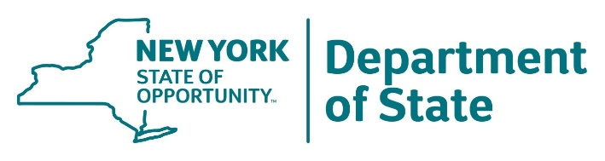

PUBLIC MEETING NOTICE

Long Island South Shore Estuary Reserve Council

Date: Wednesday, April 11, 2018

Time: 1:00 p.m.

Place: Town of Hempstead
Department of Conservation and Waterways
1401 Lido Boulevard, P.O. Box 180
Point Lookout, New York 11569

Description: The Department of State will be convening a meeting of the Long Island South Shore Estuary Reserve Council. The public has the right to attend the meeting.

Tentative Agenda:
- Call to Order
- Approval of Minutes of Meeting of October 12, 2017
- New Business
  - Town of Hempstead Programs
  - New York Shellfish Restoration Project
  - Seagrass Management
  - South Shore Estuary Reserve Office
  - South Shore Estuary Reserve – Citizens Advisory Committee Report
  - Day in the Life Program
  - Council Member Updates and Roundtable Discussion
- Adjourn

###

